**Shop Bridge**

**Shop Bridge** is a web application that helps track the different items for sale. It is an inventory management system which keeps records of the items with their name, description, price and an attached image of the same.

This project is built in **ASP.NET MVC (.NET Framework 4.7.1)**

**Used Technology:**

* **WebAPI**
* **MVC**
* **C#**
* **SQL**

**System Requirements**

* IDE Framework - **Visual Studio 2019 or higher**
* Database - **SQL Server 2012 or higher**
* OS - **Windows 8 or higher**
* **IIS** should be installed.

**Usage**

* Admin can add items in the **Create Inventory Item** section of the page.
* The added item is edit by using **Edit** button
* The added items are listed below in the **List Inventory** section of the page.
* Admin can view the **details** by clicking on each Item.
* Items can also be deleted from the specified **Delete** action button.

**Time Tracking**

* Backend Functionality - 5 min
* Analysis of requirement – ½ Hour
* Frontend Functionality - 1 hours
* Frontend Presentation - 1 hour
* Backend-Frontend Integration - 1 hours

Screenshot:

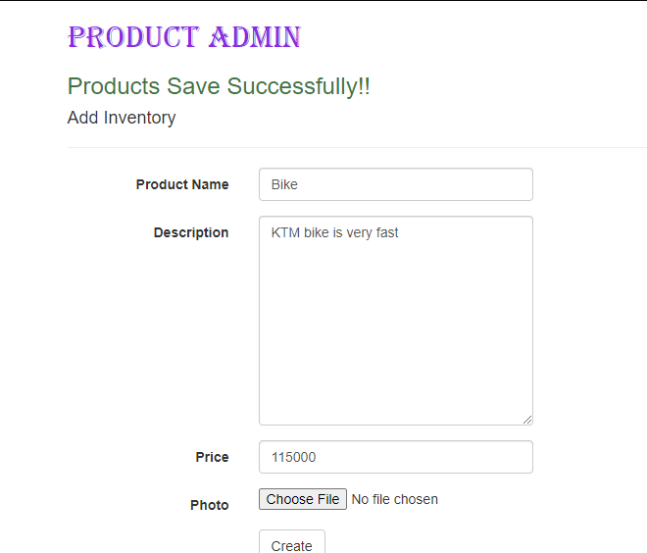

**Added product into List:**

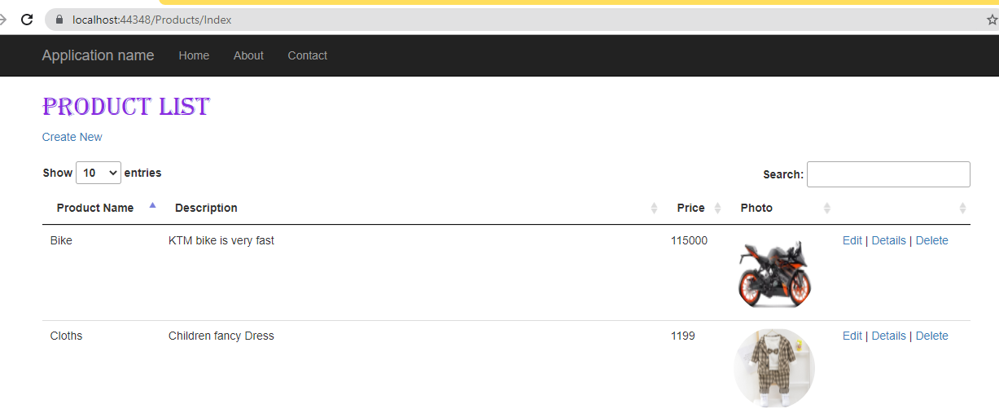

**Product List with DataTables(Pagination and searching):**

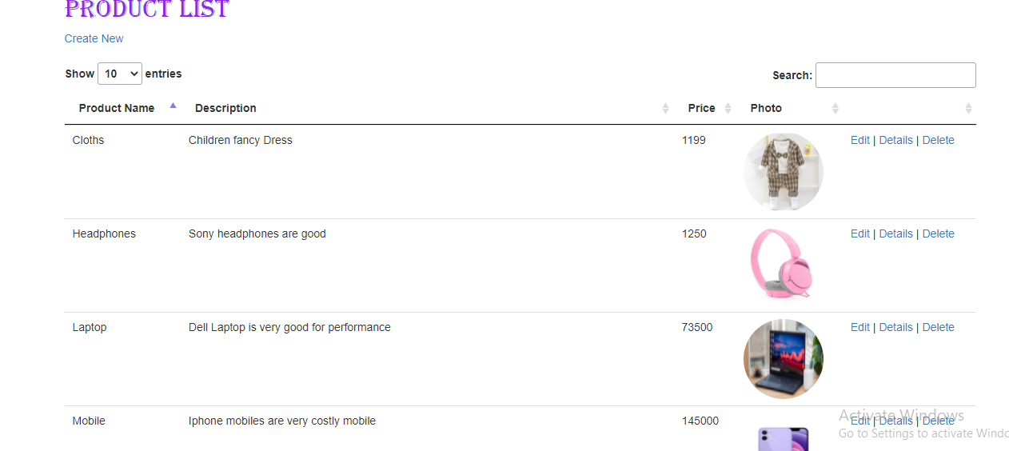

Particular product details:

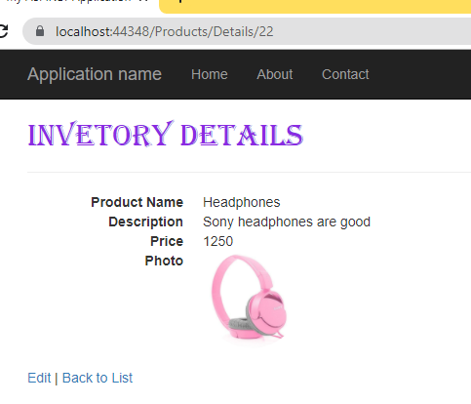

Delete Product

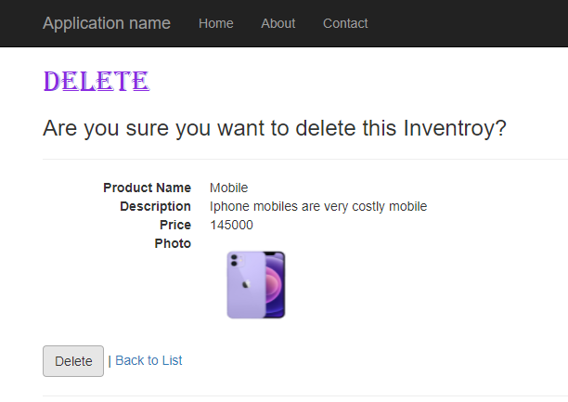

Edit Product:

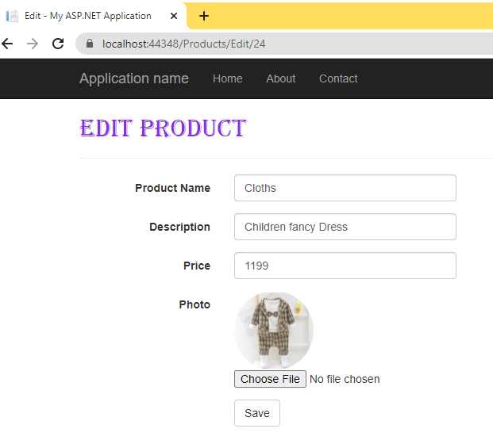

UI Validation:

